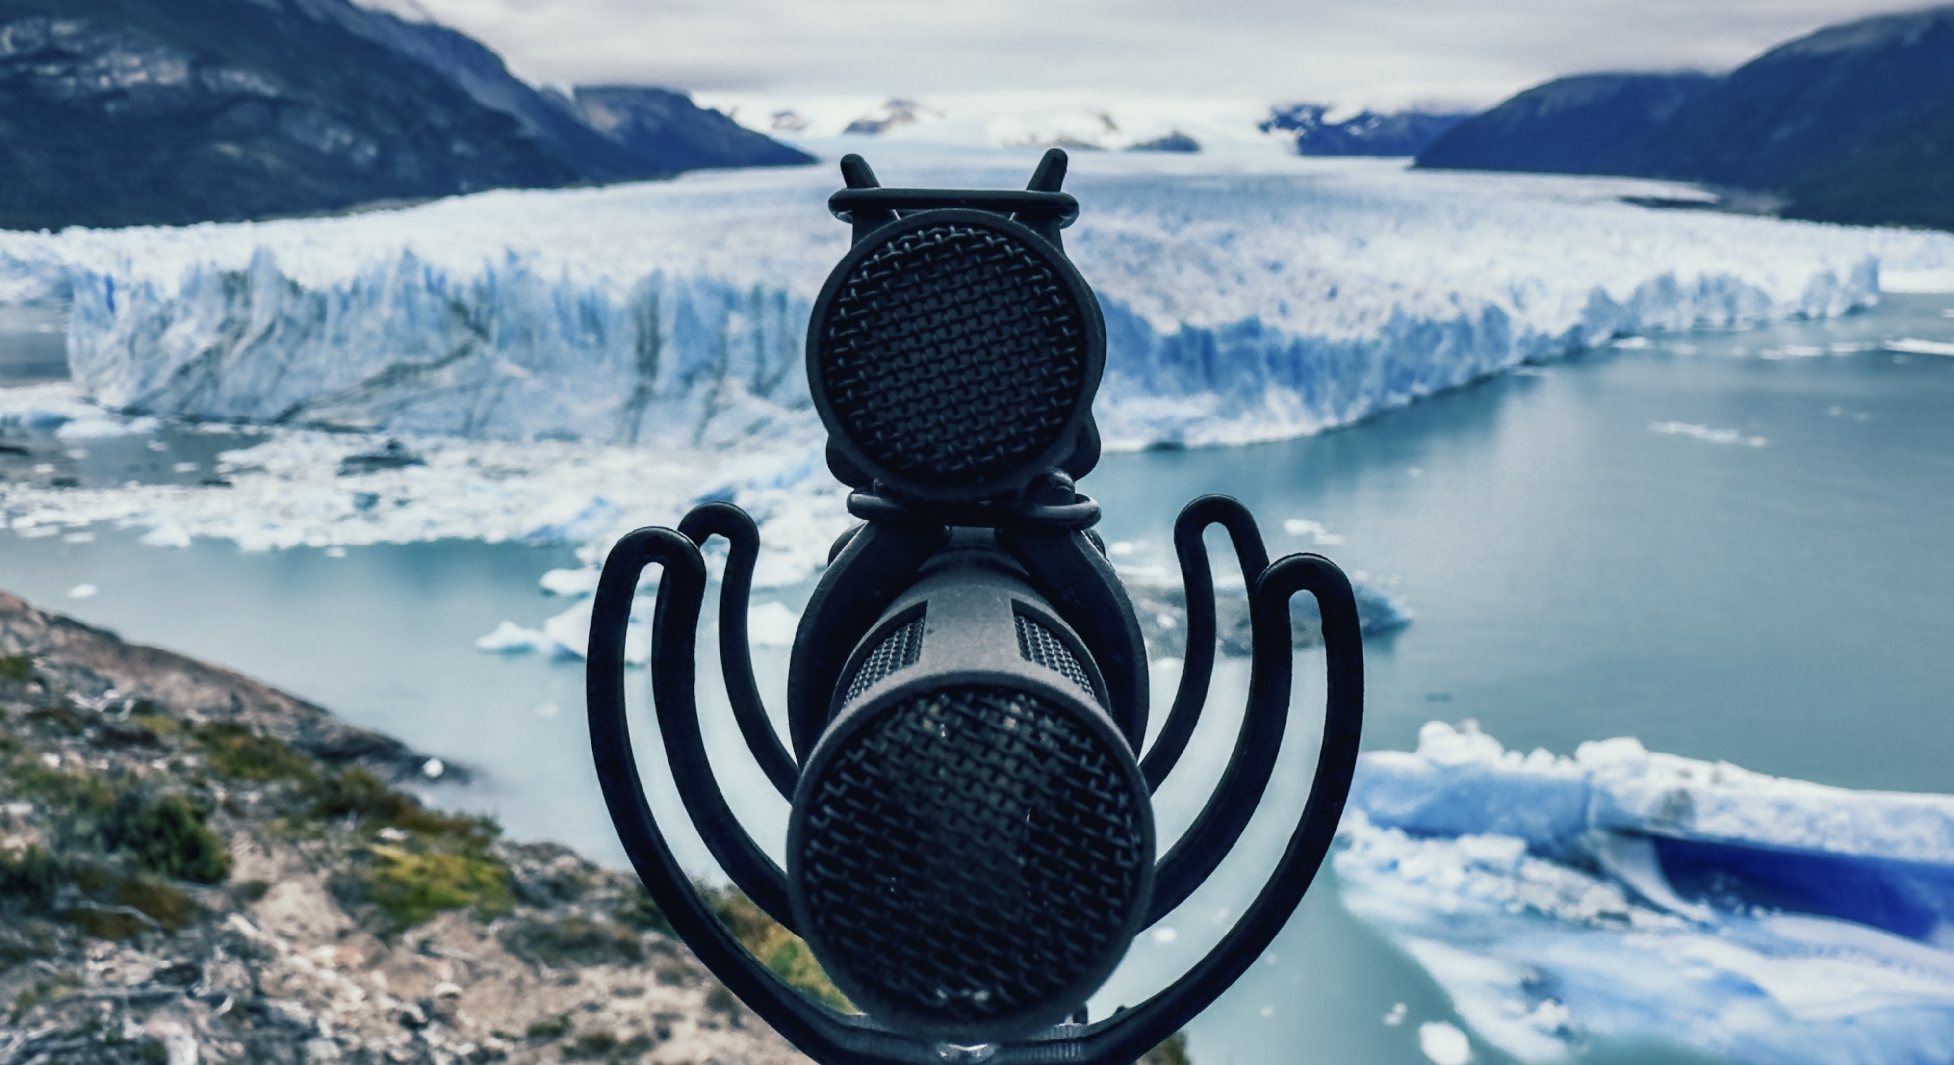

Capturing pristine audio in the most challenging places
A panel of seasoned field recordists will share their sound recording adventures with participants of Sennheiser’s RF condenser microphone seminar

Wedemark, 7 May 2024 – On May 14, some of the world’s best field recordists will take you on a virtual discovery of the most amazing places to explore and to record nature sounds, while one panellist will add an equally fascinating orchestral recording perspective. The Sennheiser seminar “Expert round table – MKH 8030” will give you insights into the panellists’ best recording tips and tricks and shine a light on a very special microphone type: Sennheiser’s MKH line of RF condenser microphones, including the new MKH 8030, which impress with fine resolution recordings and climate-proof ruggedness alike. To register for this fascinating panel, click here. The virtual, interactive event takes place on May 14 from 6 pm to 7 pm London time (5-6 pm GMT) and will leave enough room for your questions.

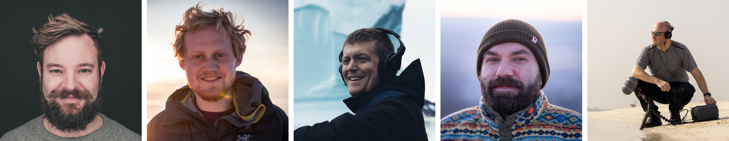
The panellists (l/r): Henrik Oppermann, Tom Martienssen, Thomas Beverly, George Vlad, and Simon Charles

From the orchestra pit to the rainforest – more about the panellists
Hosted by Tim Moore, Sennheiser Relationship Management, the expert panel will comprise:

Henrik Oppermann, M.Mus., is a 3D immersive audio specialist with over 15 years of experience in crafting soundscapes for feature films, commercials, and immersive installations. As the founder of “Schallgeber”, Henrik has been at the forefront of immersive audio since 2011, driving innovation and setting industry standards. His pioneering work spans roles such as the former Head of Sound for AMBEO at Sennheiser and currently as the Artistic Partner for Immersive Experiences at the Mahler Chamber Orchestra. Henrik’s extensive portfolio includes contributions to hundreds of virtual reality projects, in which he has captured 3D audio in diverse and challenging environments worldwide. An innovator in his field, he develops hardware and software for VR audio collaborations, continually pushing the boundaries to enhance immersive sound experiences.

Tom Martienssen is an Emmy-winning director and cinematographer. He has filmed in over 50 countries from Afghanistan to Bolivia, New Zealand to Patagonia. His passion for storytelling began when he was working with the Medical Emergency Response Team in Afghanistan. His writing from that time led to a career as a BBC World Affairs Unit journalist. During his time at the BBC, Tom covered and survived the 2015 earthquake in Nepal and worked undercover in the Middle East to report on ISIS. Tom’s passion for in-depth reporting made for a natural transition to documentaries.

Thomas Rex Beverly’s 90 plus nature sound libraries have been used extensively in the world of television, games, apps, museum exhibits and on high-profile film productions such as CODA, The Last of Us, Jack Ryan, Star Trek: Picard, Yellowstone, and Frozen II. As a nature sound recordist and composer with over ten years of experience, Beverly explores our evolving planet through sound. Through his field recordings, music, and sound art, he inspires listeners and hopes to help preserve the precious natural landscapes and their breath-taking soundscapes for future generations.

George Vlad is a sound recordist and expedition leader with more than 15 years of experience in recording the sounds of nature and wildlife. He has worked on many projects including Dune Part 2, Mufasa, the Lion King and Horizon Forbidden West. George travels extensively to remote parts of the world so that he can record and document the last remaining wild places on Earth.

Simon Charles is a highly skilled professional sound specialist for film, television, documentary, commercials, and corporate productions who delivers exceptional sound quality in any location, whether it’s a studio or a challenging outdoor environment. With advanced knowledge of digital recording techniques, microphone placement, signal flow, and audio troubleshooting, Simon ensures the capture of the best possible audio in any situation.

“Expert round table – MKH 8030” on May 14, 6-7 pm London time: Please register here.
For your social media channels:
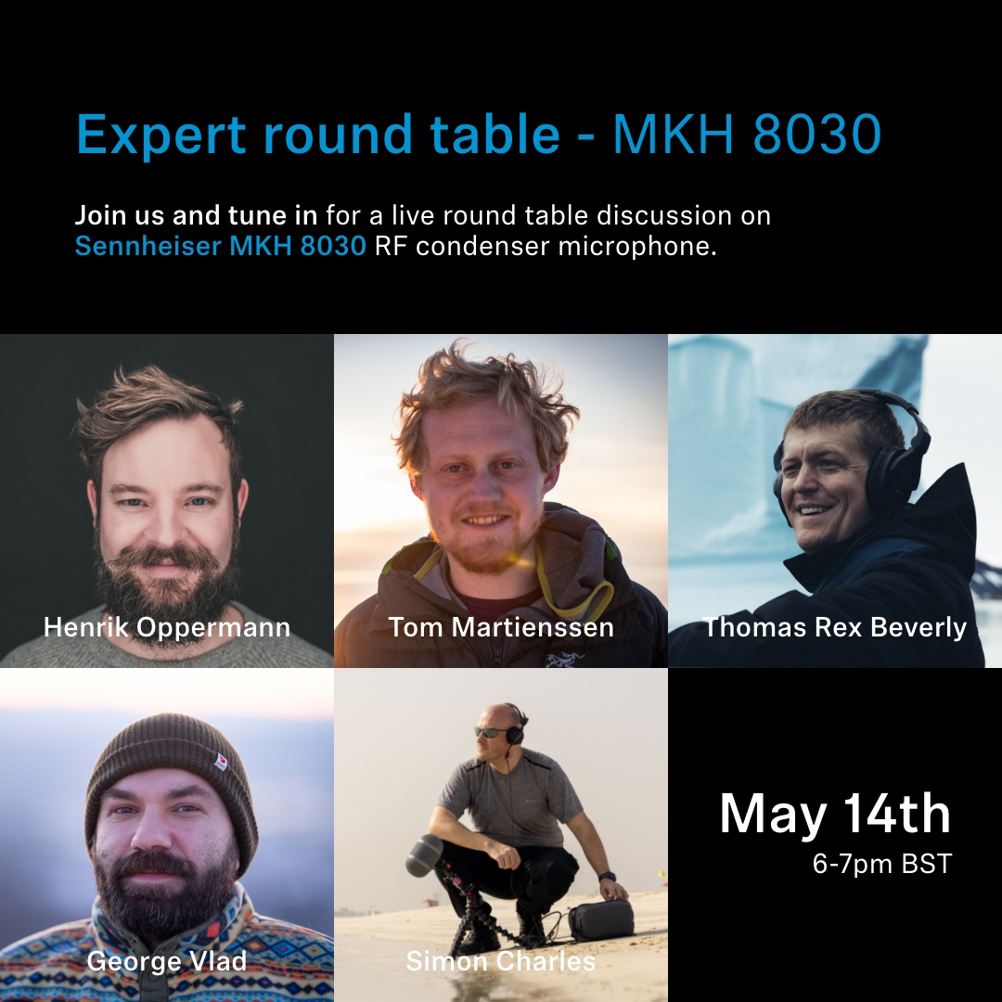 | 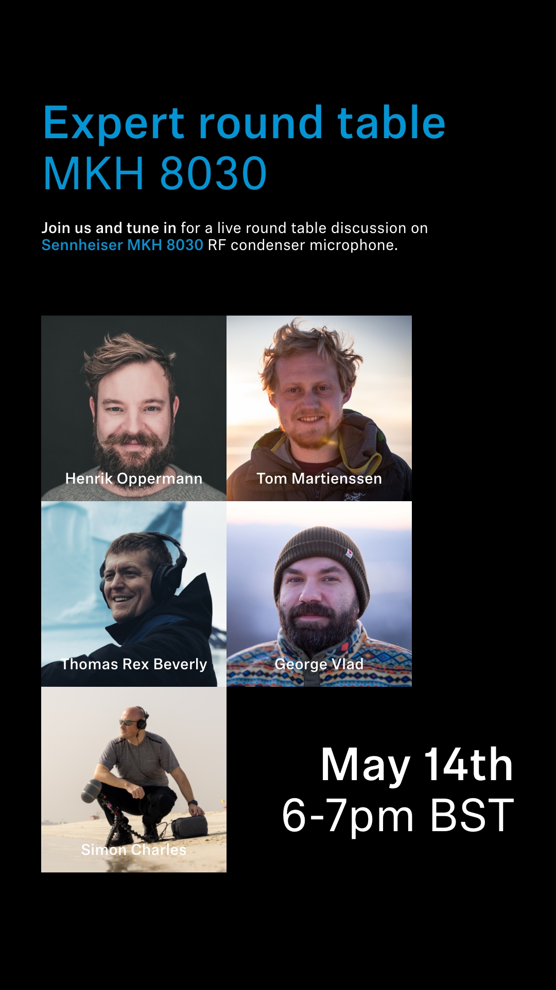

All images accompanying this media release can be downloaded here.

About the Sennheiser brand
We live and breathe audio. We are driven by the passion to create audio solutions that make a difference. Building the future of audio and bringing remarkable sound experiences to our customers – this is what the Sennheiser brand has represented for more than 75 years. While professional audio solutions such as microphones, meeting solutions, streaming technologies and monitoring systems are part of the business of Sennheiser electronic GmbH & Co. KG, the business with consumer devices such as headphones, soundbars and speech-enhanced hearables is operated by Sonova Holding AG under the license of Sennheiser.

www.sennheiser.com
www.sennheiser-hearing.com

Global Pro Audio Press Contact
Stephanie Schmidt
stephanie.schmidt@sennheiser.com
+49 (5130) 600 – 1275

